AATE and ALEA present: Capitalising on Curiosity
3- 6 July 2015
A cold and Captivating Conference in Canberra
A reflection by Imogen Gray
English teachers from around the country gathered in our nation’s capital to attend AATE and ALEA’s National English Literacy Conference. The theme of this year’s conference was inquiry, with the creative title ‘Capitalising on Curiosity’ and paid tribute to the original custodians of the land with the caption ‘ninggi warrguu’- look and ask why. Naturally, I left for the conference with a lot of questions, including, ‘how can I adapt my pedagogy to suit our digitally dependant students?’ And ‘how can I adopt an inquiry approach in an English classroom?’ These questions and many more were addressed at the conference.
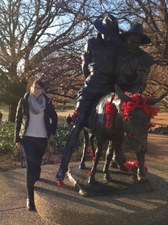
I was fortunate enough to be able to attend a pre-conference session held at the National War Memorial. As this was my first time in Canberra I was excited to visit one of Australia’s most iconic destinations that pays tribute to the many people who made sacrifices for our country. Our tour began with Peter O’Connor addressing the sensitive issue of how to address the ANZAC story in the classroom and arouse empathy. We were then taken on a tour by an educational officer and saw the museum from the eyes of a student. Fitting with the conference theme, the educational tours adopt an inquiry approach which I found to be an excellent example of inquiry through experiential learning.
Photo: Myself with the statue of Simpson and his Donkey at the National War Memorial.
The conference officially opened later that evening which I found to be an ideal networking opportunity. Drinks and canapés were served whilst we were welcomed by the organising committee and were provoked by Peter Freebody to consider ‘What curiosities in English and Literacy should we be curious about?’
The subsequent three days were a whirlwind of strategies, ideas and pedagogical approaches evoked by a number of inspiring guest speakers ranging from experts to your everyday classroom teacher. Some of the highlights for me were the keynote speakers and workshops focusing on reading comprehension and writing strategies. As a secondary teacher, I have found that the focus of professional learning opportunities tend to be based on the assumption that students are already armed with strategies to be successful readers and writers. In the few years that I have been teaching I have learnt that this is not always the case. I was very excited to attend my first workshop with the highly regarded authors of The Writing Book, Sheena Cameron and Louise Dempsey. They really inspired me to encourage my students to improve their writing at the sentence and word level. Their concept of a ‘super sentence’, one that includes numerous parts of speech (as determined by the teacher) seems to be a very effective strategy and one that I am keen to adopt in my classroom. They encourage older students to ‘pimp their sentence’ in order to improve their writing.
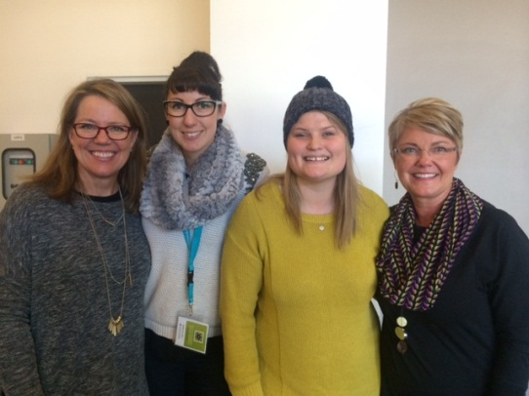
The other equally engaging writing and reading gurus were ‘the two sisters’ Gail Boushey and Joan Moser. They presented two of their key strategies including The Daily 5 and CAFÉ which focus on engaging students in reading and writing and arming them with strategies to allow them to be in control of their learning and to set goals for themselves through individualised programs. I was lucky enough to meet these two inspirational women between their sessions.
Photo: Myself and TATE scholarship winner Mel Collet (middle right) with Gail and Joan.

I found all of the sessions that I attended motivating and useful to me in various ways. Sessions that particularly resonated with me related to using digital technologies to improve engagement and performance, the use of role play and poetry, as well as the inclusion of memes and podcasts. I also attended a session run by our very own TATE president Erika Boas, focusing on the power of an inquiry based approach in the English classroom which I found to be informative and thought provoking.
By the time the conference officially closed on Monday afternoon my head was buzzing with ideas that I couldn’t wait to try out in the classroom, and a suitcase overflowing with books!
I will end with my sincere gratitude for being provided with the opportunity to attend the national English Literacy conference in Canberra. Firstly I would like to thank NEAT for providing me with the very generous scholarship and secondly to Erika Boas for forwarding my application with her recommendation to NEAT. I would also like to thank St Virgil’s College for their assistance in providing me with this incredible opportunity.

Imogen Gray

